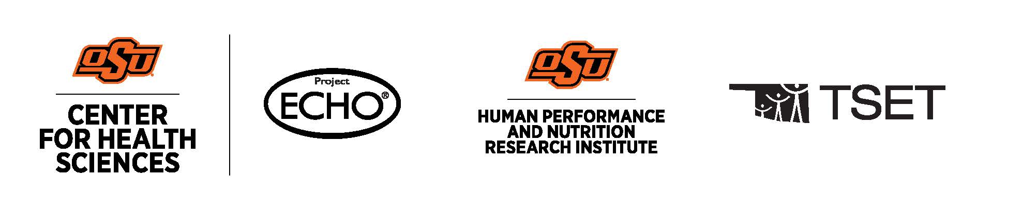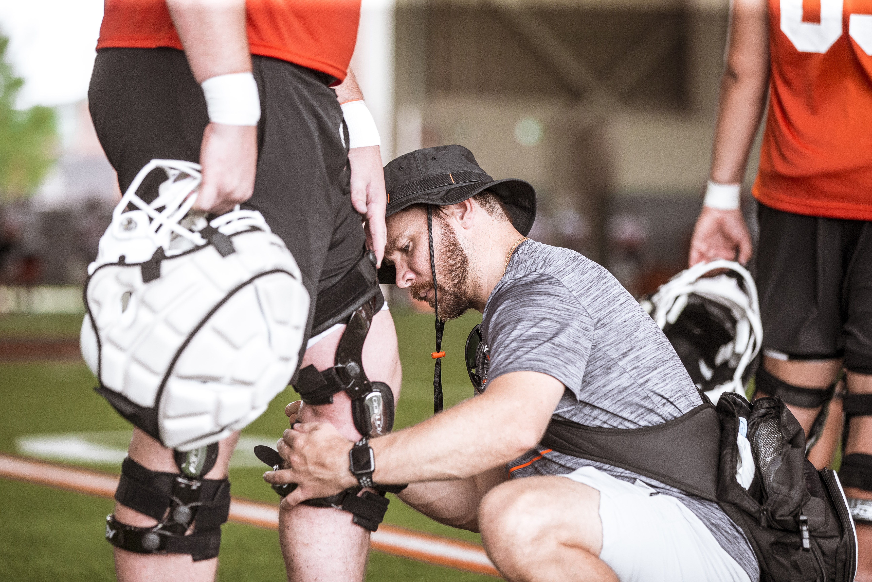  Tiered Resilience: Load Management in Team Sports  Learning Objectives  1. Differentiate between external training load and internal training load by identifying and classifying at least three valid metrics for each construct (e.g., GPS-derived measures, repetitions, RPE, heart rate) in accordance with current sport science literature.  2. Explain the concept of load as a multidimensional construct by describing the constitutive and operational definitions of load and summarizing how mechanical, physiological, cognitive, and contextual factors contribute to athlete load in team sport environments.  3. Create a basic load management strategy that accounts for role variability (e.g., starters, rotation, bench), competition demands, and logistical strain, with the goal of supporting player availability and performance.  Schedule and Format  - Wednesday, February 11, 2026; 12-1:00pm  Cancellation/Refund Policy  - None. No payments necessary.    Oklahoma State University Center for Health Sciences Office of Continuing Medical Education (BOC AP#: P12117) is approved by the Board of Certification, Inc. to provide continuing education to Athletic Trainers (ATs). This program is eligible for a maximum of (1.00) Category A hours/CEUs. ATs should claim only those hours actually spent in the educational program.
  Jennifer Strickler, PhD, ATC, LAT
  ____
  NO REQUIRED MATERIALS OR EQUIPMENT
  ____
  1-HOUR CATEGORY A CEU AVAILABLE
  ____
  TSET Grant
  NO FEES
  ____
  SESSIONS ARE VIRTUAL VIA ZOOM
  OSU CENTER FOR HEALTH SCIENCES
  1111 W 17th St
  Tulsa, OK 74107
  918-561-8255
  Register:
  https://redcap.okstate.edu/surveys/?s=3KY39MLMMHKCCHMY
  Website
  https://medicine.okstate.edu/echo/atsm-echo.html

